Quant class 3

https://www.facebook.com/events/1543629585758705/

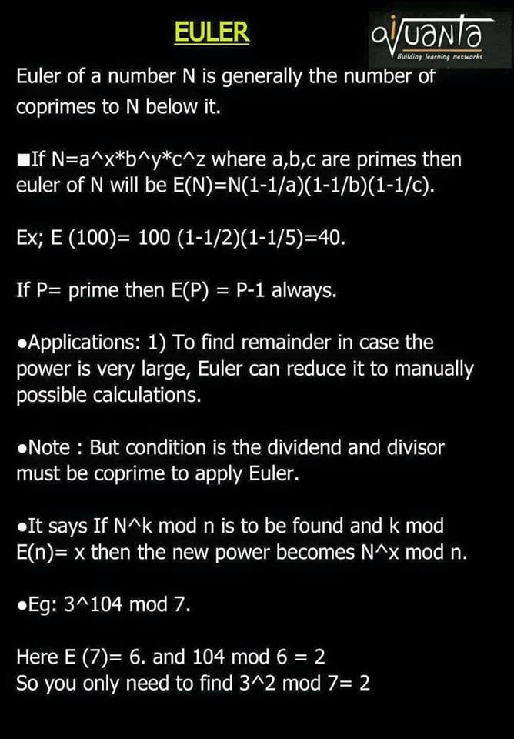

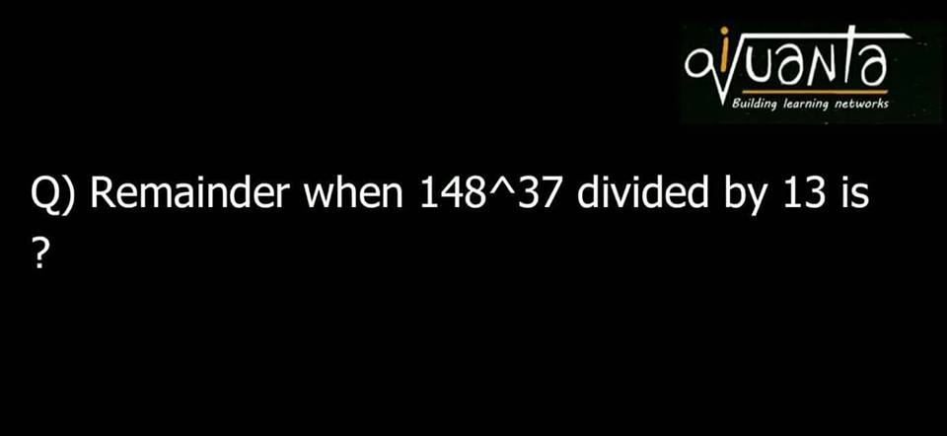

OA : 5

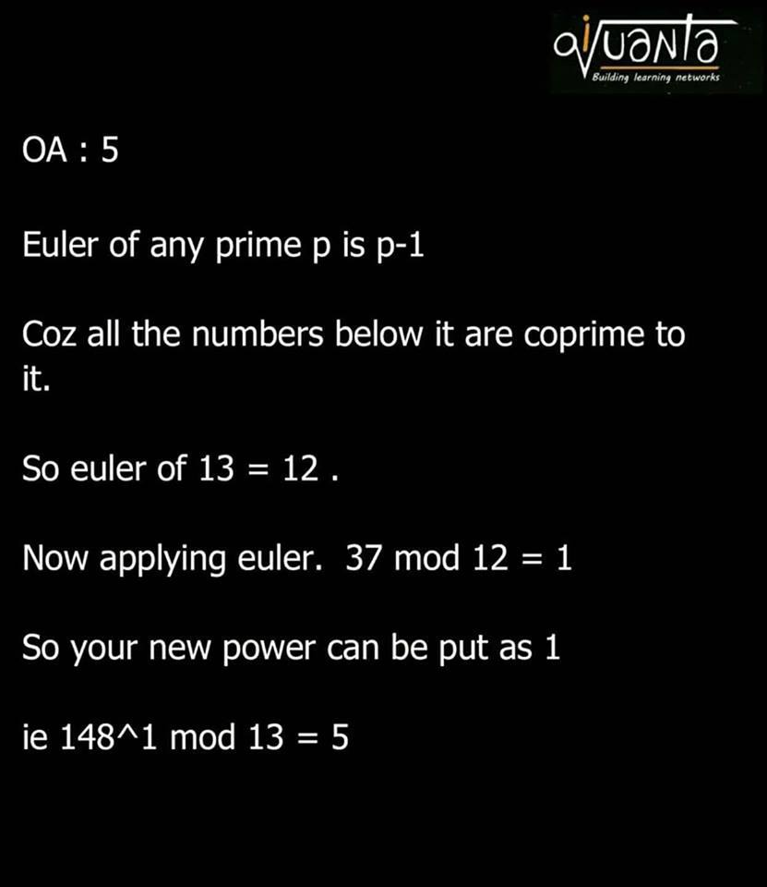

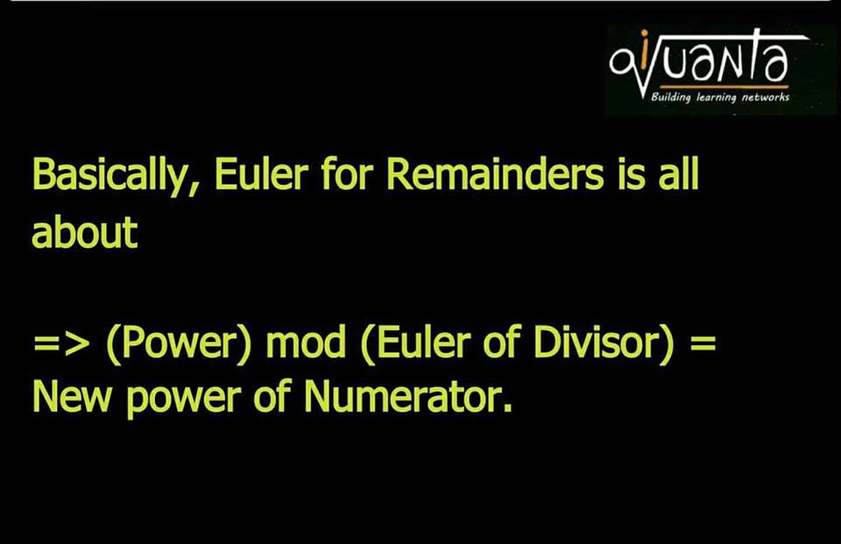

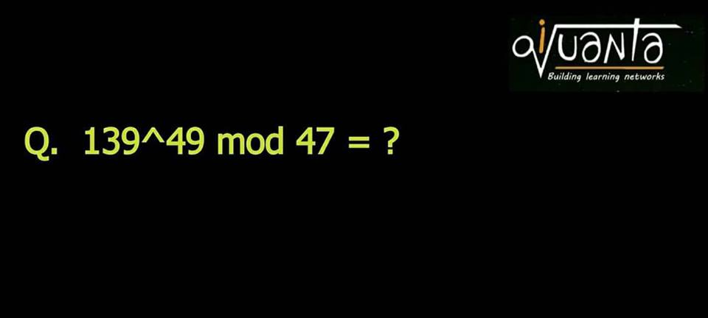

E(47) = 46

47 mod 46 = 3.

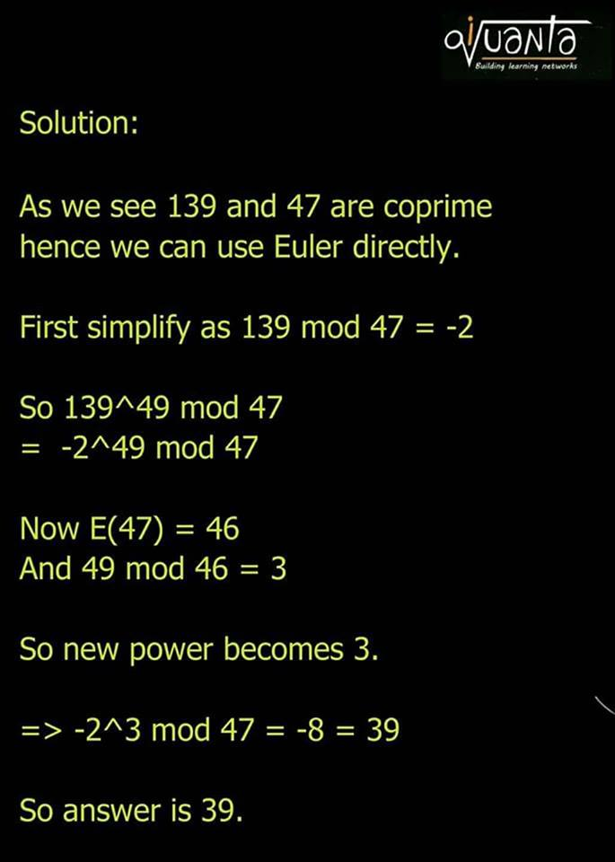

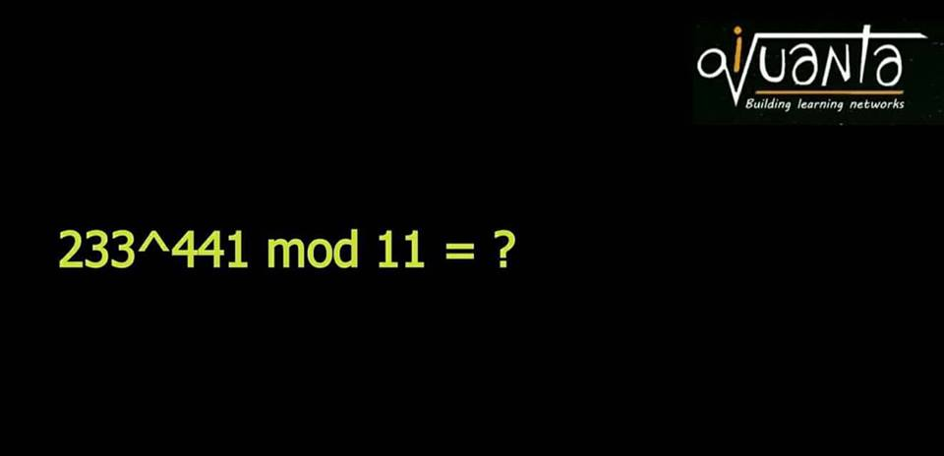

Ans : 02

e(11) = 10.

441 mod 10 = 1.

233 mod 11 = 2.

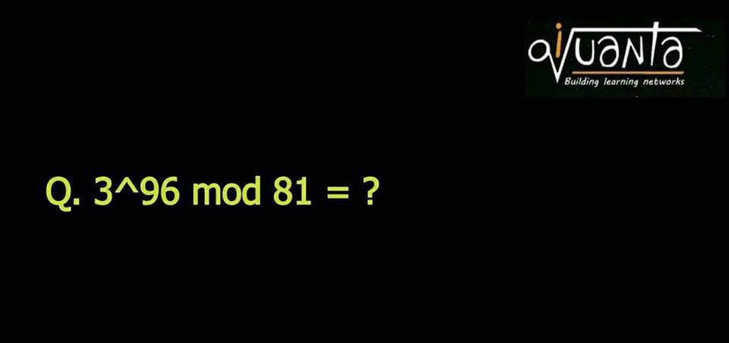

Oa: 0  
  
Solution:   
  
As 3 and 81 aren't coprime so we can't use Euler directly.   
  
Now 3^96 = 81^24   
  
So 81^24 mod 81 = 0

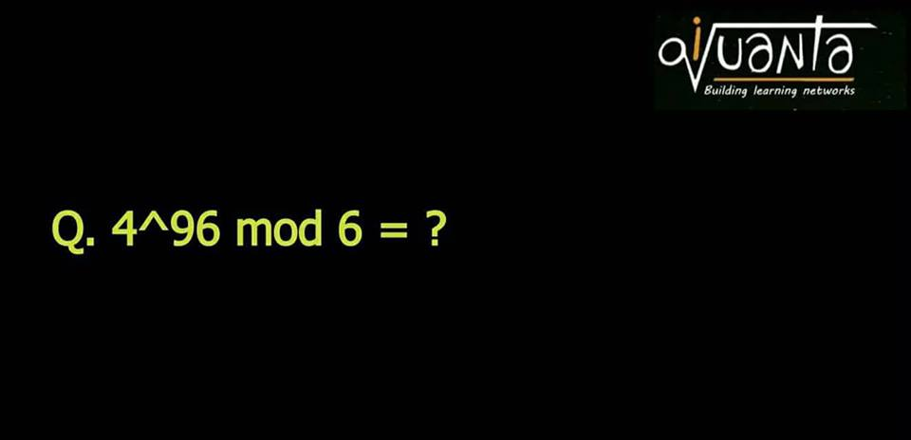

1) iQuanta shortcut   
  
4^anything mod 6 = 4 .  
  
● 2) as they aren't coprime so we can't apply euler. So first cancel common terms   
  
2^191 mod 3 = -1^odd = -1= 2   
  
Now as 2 got cancelled earlier so multiply it back to get 2*2=4.   
  
● 3) CRT which I'll explain in the next concept post .  
  
6=2*3. So find separately   
  
4^96 mod 2 = 0   
4^96 mod 3=1   
  
So R= 2a=3b+1  
a=2,b=1 satisfies to give R = 4

Guys learn to play with remainders negative concept or positive remainder concept. [#Basics](https://www.facebook.com/hashtag/basics?source=feed_text&story_id=1543729895748674) means ek hi remainder ko hum dusre form me bhi likh sakte hn apni calculation k hisab se jo easy lage.

Eg. 106 mod 12 = 10 = -2 = 22 ... etc

or when divisor is 3

1 = -2 , 2=-1... you can use anything which gives easier calculation

or when divisor is 37  
1 = -36  
2=-35  
3=-34  
.  
.  
35=-2  
36=-1

Anyway you can solve.

CAT asked a direct problem on this once

106*110*142*146 mod 12 = ?

= -2*2*-2*2 = 16 mod 12 = 4

N = a* divisor + renainder   
  
So ax10 + remainder  
Keep putting any value to a  
  
At a =2 it's 22



wrong. Observe carefully.   
  
E (37) = 36   
  
Which means   
  
12^108 mod 37 = 1 . ( Euler )   
  
12*12^107 mod 37 = - 36. ( negative remainder)  
  
12^107 mod 37 = -36/12= - 3   
  
12^107 mod 37 = - 3 = 34   
  
So 34 is the answer. ( This is back euler)

We know 3^100 mod 101=1. (Euler)  
  
3*3^99 mod 101 = 1 = 102   
  
3^99 mod 101 = 102/3 = 34.  
  
Oa: 34  
  
Now think why I took 1 = 102



oa : 29

e(101) = 100.

7^100 mod 101 = 1

7 * 7^99 mod 101 = 101*2 + 1 = 203

7^99 mod 101 = 29

E (101) = 100   
  
So 7^100 mod 101 = 1   
  
=> 7*7^99 mod 101 = 1   
  
Now express rhs 1 such that it's divisible by 7   
  
1 = 101k+1 = 203   
  
So 7*7^99 mod 101 = 203   
  
7^99 mod 101 = 203/7 = 29  
  
Most correct https://static.xx.fbcdn.net/images/emoji.php/v9/e40/1/16/LIKE.png(y)

12. ●Remainder concept

Guys see, Lets assume 11 mod 3 = 2

Now basically remainder is of the form 3k+2, and 2 is the smallest positive value which we finally call as Remainder.

But in case of general calculation you can represent Remainder 2 with 3 as 3k+2 where k is an integer,

So k=-1, R = -1   
K=1, R = 5  
K=2, R=8  
.  
. Like this

Means we can represent it in any of the above form which suits our calculation, jus that last me apan smallest positive value likhte hain

Ex 3^99 mod 101

Wr already know that 3^100 mod 101 = 1 (euler)

3*3^99 mod 101 = 101k+1

Now we will find that value of 101k+1 such that it is divisible by 3 in LHS. So k=1, R=102 satiafies

Hence 3^99 mod 101 = 102/3=34

If you get it like this post.



e(101) = 100.

3^100 mod 101 = 1 = 4*101 + 1

9 * 3^98 mod 101 = 405

3^98 mod 101 = 45

We know that 3^100 mod 101 = 1  
  
9*3^98 mod 101 = 101k+1,   
  
Now find a value of k such that 101k+1 is divisible by 9 , k=4 satisfies   
  
So 9*3^98 mod 101 = 405  
  
3^98 mod 101 = 405/9= 45   
  
Jisko samajh aa gya thoko like jisko ni aya comment.

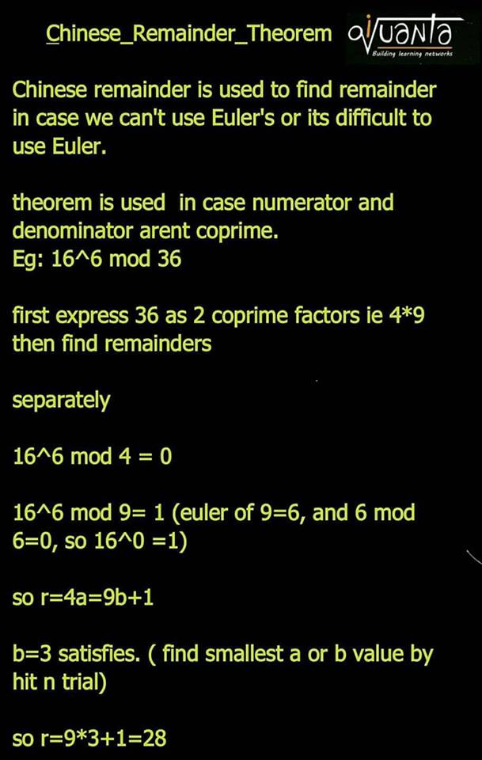



 341 isn't prime. So it's euler isn't 340.  
  
341 = 11*31   
  
3^340mod31 use euler to convert it into  
3^10 mod 31  
243^2mod 31  
(-5)^2mod31  
25mod31 so 25  
  
And 3^340 mod 11 = 1   
  
So 31a+25=11b+1  
  
31a+24=11b  
a=1 satisfies   
  
So R = 31*1+25 = 56

Q. 46^47 mod 36 = ?

36= 4*9 ( coprime pairs)  
  
46^47 mod 4 = 0   
  
46^47 mod 9 = 1   
  
4a = 9b+1  
  
a=7, b=3 satisfies to give R = 28

3^268 mod 22

 22 = 2*11   
  
3^268 mod 2 = 1   
3^268 mod 11 = 3^8 mod 11   
= 81*81 mod 11 = 4*4 mod 11 = 5  
  
so 2a + 1 = 11b + 5  
  
2a = 11b+4  
b=0, satisfies  
  
so R = 5

Sabke doubts ek sath lenge next class se pehle pehle. Tab tak sab cover krlo..

1) 341*451*333 mod 39  
2) 11^111 mod 7  
3) 1111^1111 mod 16  
4) 1967^ 657 mod 120  
5) 999^999 mod 22  
6) 755^855 mod 24  
7) 899^677 mod 12  
8) 888^67^11 mod 21  
9) 11^67 mod 21  
10) 23^67 mod 41

1 . 21 ; 2. 1 ; 3. 7 ; 4. 47 ; 5. 5 ; 6. 11 ; 7. 11 ; 8. 6 ; 9. 11 ;10. 4

Take 2 examples : 1) Euler 139^49 mod 47  
2) back euler 12^107 mod 37  
  
1) if you see E(47)= 46  
  
And 49 mod 46= 3   
  
Power has become very small hence its good this way ie normal way  
  
2) E(37)= 36   
  
And 107 mod 36 = 35   
  
Haf it been 108 instead then it would be 108 mod 36 = 0   
  
Means smallest  
  
Hence we need one more power  
  
So will take 12^38 mod 37 =1   
  
Now we need 12^37  
  
So 12 x 12^37 mod 37 = 1   
  
Then convert by taking 12 to RHS  
  
Here back euler preferred